1- Initialize a Git Repository
git init repo

2- Add files to the repository
git add file1.java
git add file2.java
git add file3.java
OR
gir add '*.java'

3- Unstage 1 file
git rm --cached file2.java

4- Commit the files
git commit -m "file1.java,file3.java added"

5- Add a remote
git remote add origin git@github.com:nitin-singh/practice.git

6- Undo changes to a particular file
gedit file1.java
git checkout -- file1.java

7- Push changes to Github
git pull origin master
git push

8- Clone the repository
git clone git@github.com:nitin-singh/practice.git

9- Add changes to one of the copies and pull the changes in the other.
made changes to file3 of "practice" repo which is the clone.
pushed changes of clone using: nitin@nitin:~/practice$ git push
Then switched to other repository on the system and made a pull request using:
nitin@nitin:~/repo$ git pull origin master

10- Add changes to both repos, try to push from both without taking a pull.

made changes to clone repository and pushed the changes using command:
nitin@nitin:~/practice$ git push
and these changes were successfully pushed.

Then made changes to second repository and tried to push using:
nitin@nitin:~/repo$ git push

which resulted in error.

Then i had to forcefully push using:
nitin@nitin:~/repo$ git push origin master -f

which resulted in loss of changes which were made in clone repository.

11- Check differences between a file and its staged version
Command: git diff
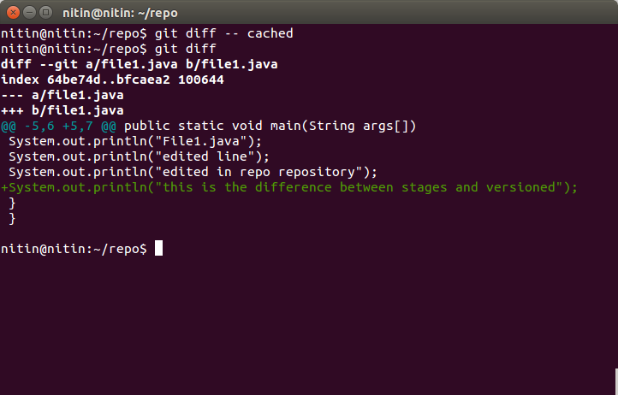

12- Ignore a few files to be checked in
doubt

13- Create a new branch. Diverge them with commits

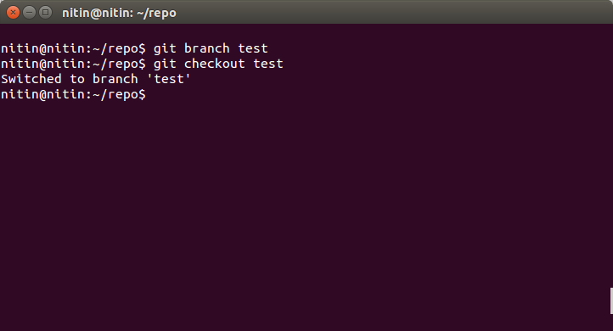
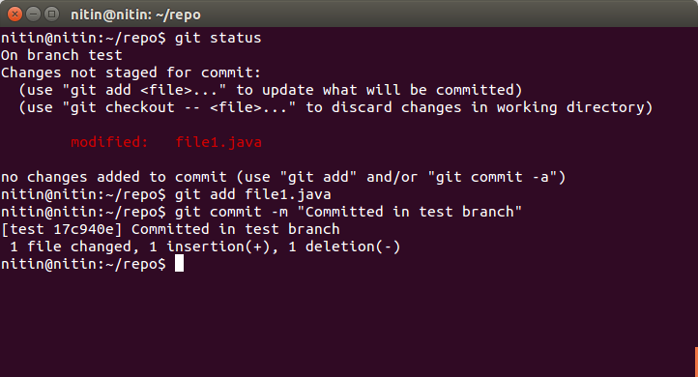
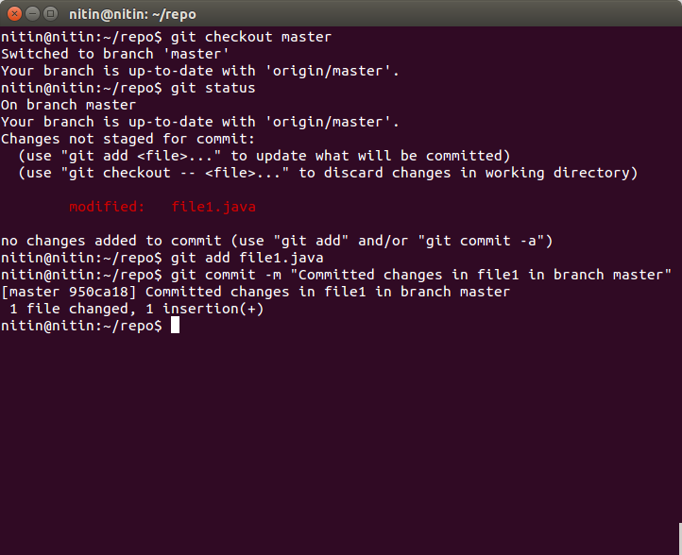
14- Edit the same file at the same line on both branches and commit

edited file3.java in both clone and repo repository.
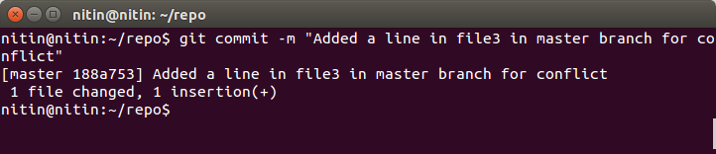
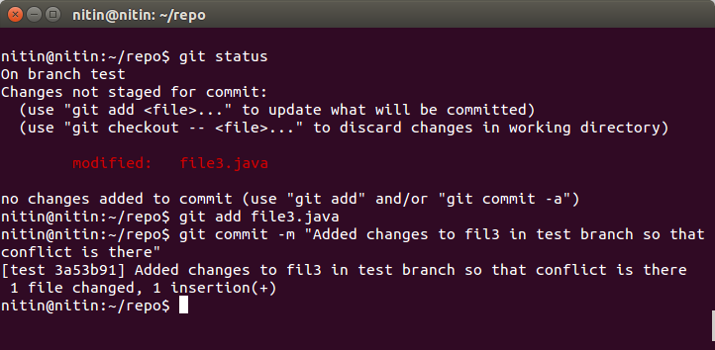

15- Try merging and resolve merge conflicts

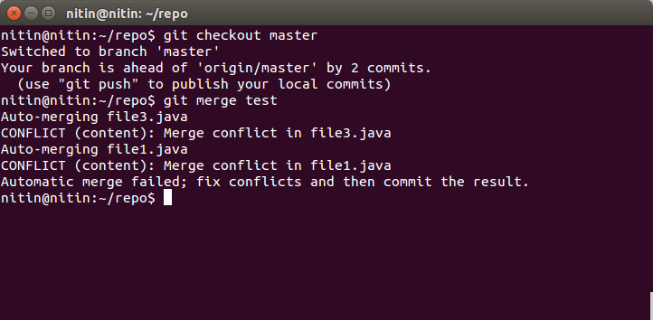
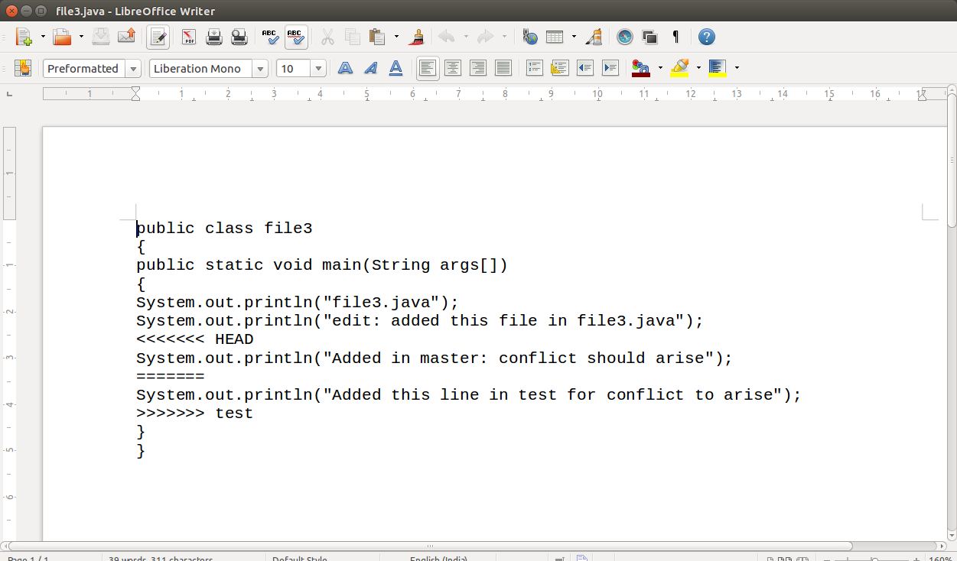
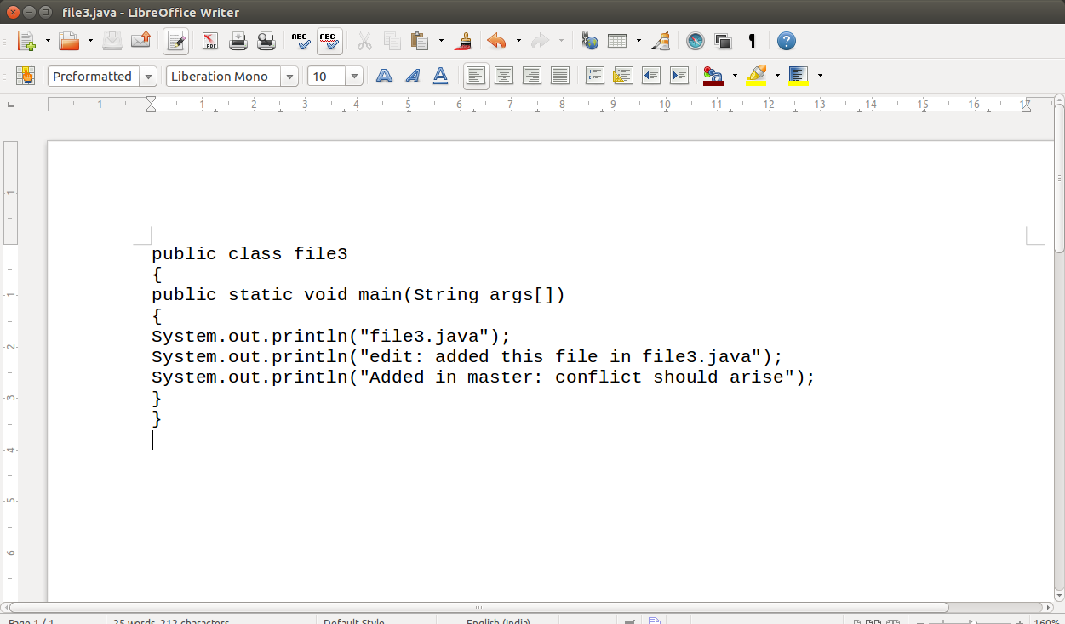
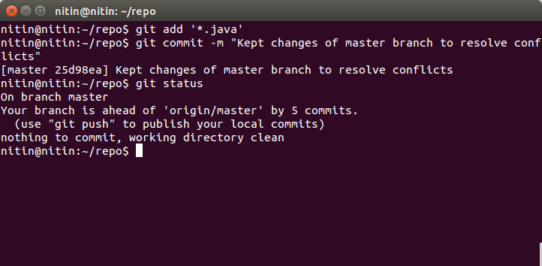

16- Stash the changes and pop them
